**HEATING CYCLE 1**

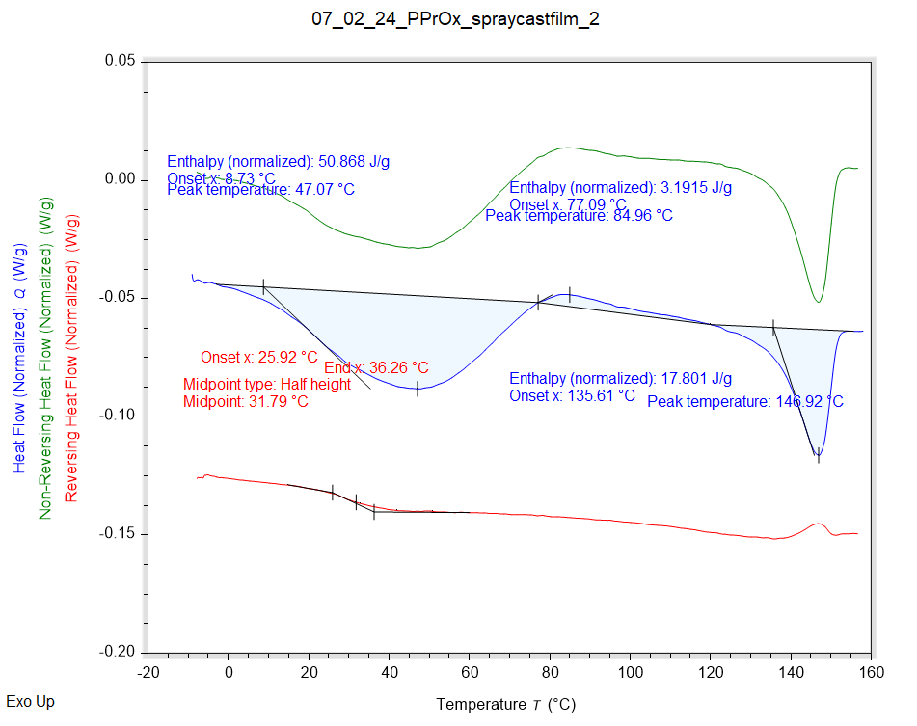

|  |  |  |  |
| --- | --- | --- | --- |
| Solvent HC1 | Peak Onset | Peak Location | Enthalpy |
|  | 8.729 °C | 47.072 °C | 50.868 J/g |

|  |  |  |
| --- | --- | --- |
| Recrystallisation HC1 | Peak Onset | Peak Location |
|  | 77.093 °C | 84.959 °C |

|  |  |  |  |
| --- | --- | --- | --- |
| Melting HC1 | Peak Onset | Peak Location | Enthalpy |
|  | 135.614 °C | 146.918 °C | 17.801 J/g |

|  |  |
| --- | --- |
| Tg HC1 | Onset |
|  | 25.922 °C |